**Finalization :**i)TID , Tname

ii) PID ,Pname , age , phone , address , TID(FK)

iii)CID , Cname , phone , TID(FK)

iv) SID , Sname , Phone , TID(FK)

v) SOP_ID , SOP_name , Amount  
vi) TID , SOP_ID(FK)  
vii) MID , M_Loc , Date

viii) AUID , AUname

ix) MID , AUID(FK)

x) TID , Tname , MID (FK)  
xi) PID ,Pname , age , phone , address , CID(FK)

xii)CID , Cname , phone

**Table creation :**i)TID , Tname   
  
  
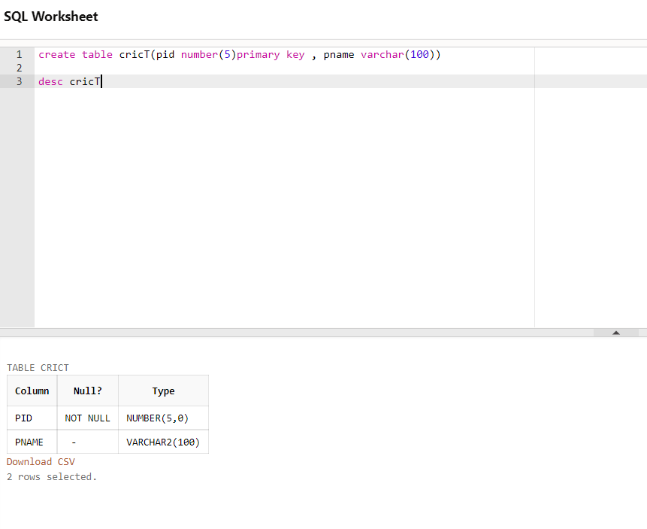

ii) PID ,Pname , age , phone , address , TID(FK)

iii)CID , Cname , phone , TID(FK)

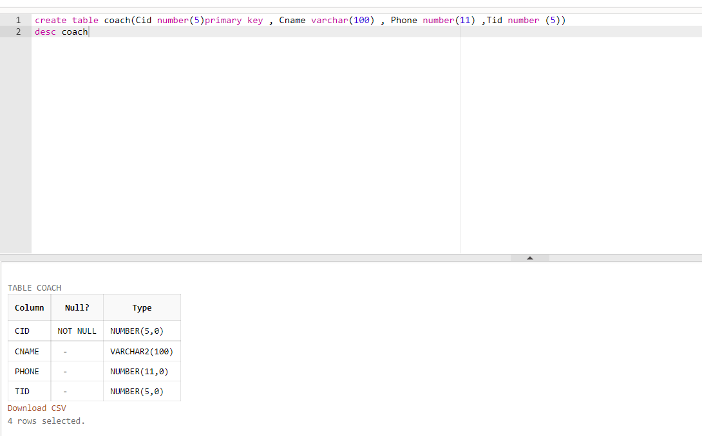

iv) SID , Sname , Phone , TID(FK)

v) SOP_ID , SOP_name , Amount

vi) TID (FK), SOP_ID  
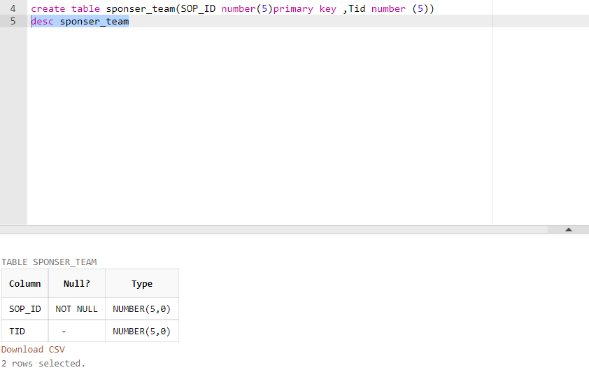

vii) MID , M_Loc , Date

viii) AUID , AUname

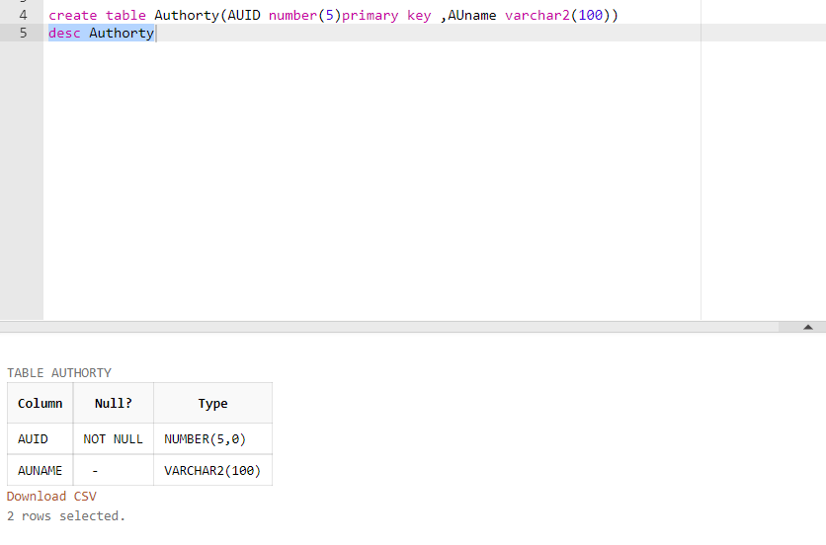

ix) MID , AUID(FK)

xi) PID ,Pname , age , phone , address , CID(FK) 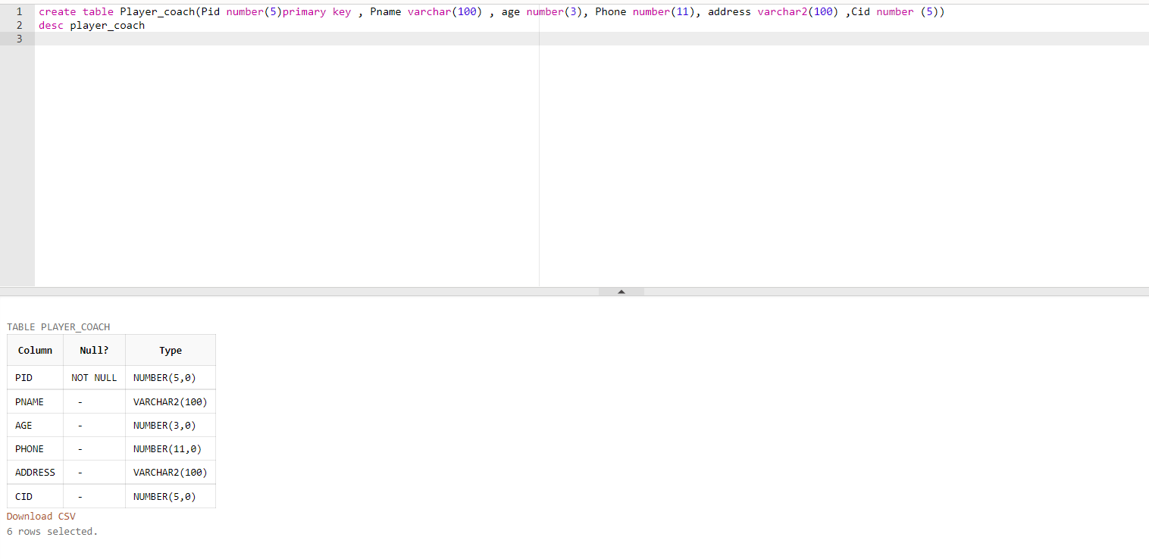

xii)CID , Cname , phone

